COMPUTING SUBJECT: Secure Socket layer

TYPE: Assignment

IDENTIFICATION: SSL

COPYRIGHT: Michael Claudius

LEVEL: Easy

TIME CONSUMPTION: 1-2 hours

EXTENT: 50 lines

OBJECTIVE: SSL sockets in practice

PRECONDITIONS: Computer Networking Ch. 8.5

COMMANDS:
IDENTIFICATION: SSL/LV&MC

The Mission
You are to make a secure connection by setting up a server and a client using the secure socket layer and sharing the certificate provided by the server.
NetBeans is recommended, but can also use your favorite editor

Useful links for this assignment

JAVA + SSL Tutorial (server and client examples) Simple and good example
Build secure network applications with SSL and the JSSE API Special description
Installing and Configuring SSL Support Detailed description and SSL installing
The J2EE(TM) 1.4 Tutorial The sun tutorial for using SSL; quite advanced
Keytool - Key and Certificate Management Tool Solaris Programmers tool to create keys
Keytool – Key and Certificate Management Tool Windows Programmers tool to create keys

1. Local server and client on one computer
First download the project SSLProject with the normal EchoServer & EchoClient classes and the special class SSLContextFacade class from your teacher’s homepage.
Open Netbeans or another editor and compile the EchoServer and EchoClient as they are.
Run the EchoServer and EchoClient.
Type something in the client Window.
Test the communication.

2. Use of Secure Sockets
You are now to change the echo-application to use Secure Socket Layer (SSL).

Modify the EchoServer to use a secure Socket instead of the ServerSocket by substituting the lines just after “try” by:

SSLServerSocketFactory sslserversocketfactory =
(SSLServerSocketFactory)SSLServerSocketFactory.getDefault();
SSLServerSocket sslserversocket =
(SSLServerSocket)sslserversocketfactory.createServerSocket(9999);
SSLSocket sslsocket = (SSLSocket)sslserversocket.accept();

Remember to import the ssl package:

import javax.net.ssl.SSLSocket;

in the beginning of the program.

In the same way modify the EchoClient to use a secure Socket instead of the plain Socket

SSLSocketFactory sslsocketfactory = (SSLSocketFactory)SSLSocketFactory.getDefault();
SSLSocket sslsocket = (SSLSocket)sslsocketfactory.createSocket("localhost", 9999);

3. Executing server and client
Compile and run the server program.
Now you get an error?! Why? What is missing ?
Think! Don’t turn page.
4. Generating a certificate fast
I said don’t look! ☺ ☺.
We need to generate a certificate file; i.e. a KeyStore file with the chosen key pair, the chosen cryptography method (RSA & MD5, DSA&SHA1) and other standard information.
This can be done fast from a terminal window i.e. NOT from the editor NetBeans/TextPad:
Open a terminal window:
Start -> Run -> OK (for cmd)

Now generate a KeyStore certificate file for keys , type:

keytool -genkey -keystore myKeystore -keyalg RSA

You will be prompted for some standard information and keys. Answer correctly.
When accepted, close the window and move the file to the folder with your .java and .class files.

More general information and information on DSA can be found on:
http://java.sun.com/j2se/1.5.0/docs/tooldocs/windows/keytool.html)
http://en.wikipedia.org/wiki/Digital_Signature_Algorithm (DSA)

5. Executing server and client
To execute the server and client program we now need to specify the use of the KeyStore file.
In NetBeans. Find the <default configure> list box and choose customize.
Or right click on SSLProject -> Properties
This opens a window like:

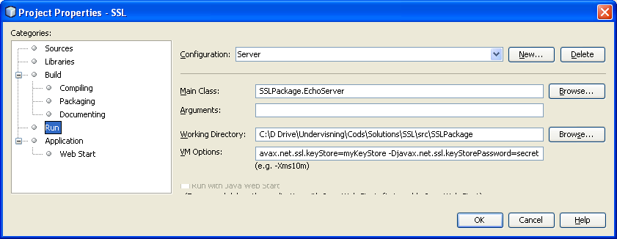
Give the following as main class:
SSLPackage.EchoServer

and the following as VM Options (with the password used e.g. secret):

-Djavax.net.ssl.keyStore=myKeystore
-Djavax.net.ssl.keyStorePassword=secret

and maybe your own working directory. Finally click OK.
Then execute the EchoServer as a main class.
Remember this requires that the SSLProject is configured as the main project.

In the same way create a client configuration and run the client but this time use the following command and parameters:

SSLPackage.EchoClient
-Djavax.net.ssl.trustStore=myKeystore
-Djavax.net.ssl.trustStorePassword=secret

and click OK.
Then run the client.
Test the communication………

Note: Instead of using the Netbeans , one can use TextPad or terminal window see appendix A & B.

6. Server and client on two different computers
This assignment is best performed by pairs of students and on the fast-net, as there are restrictions on the wireless net (Alternatively you can use the Uber unsecure network….)
Lookup the IP address of the server computer. ( eg. Click: start -> run -> cmd -> 'type ipconfig').
Start the EchoServer on one computer.
Modify the EchoClient to create a socket to the server (your partner) ie. change “localhost” to the IP-address of the server.
Start the WireShark (i.e. start -> capture -> interface -> open)
Run the client and start to communicate.
Stop WireShark and view the captured packets.
You should now be able to read the package content given as plain text.

Then try to do exactly the same for the SSL based EchoServer and SSL based Echoclient.
Hopefully you now can not see the plain text but only cipher text!

7. How to open keyStore within your JAVA application. (Extra assignment for the fast ones)
You can of course choose to open the KeyStore file from your program instead of using parameters to the execution.
From your teacher’s home page download the java class SSLContextFacade, which is also given in Appendix C.
Look at the code line by line. Clear !?
Try to use this class in your EchoServer and EchoClient.
Now you can run as usual from Netbeans.
App. A Use of TextPad
Start Textpad. Load the EchoServer and EchoClient. Compile both (Tools -> Compile).
To run the server choose: Tools -> Run …
This opens a window like:

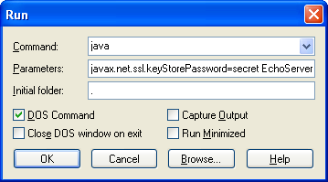

Give the following command and parameters (with the password used e.g. secret):

java
-Djavax.net.ssl.keyStore=myKeystore -Djavax.net.ssl.keyStorePassword=secret EchoServer

and click OK.
Now the server is running.

In the same way run the client but this time give the following command and parameters:

java
-Djavax.net.ssl.trustStore=myKeystore
-Djavax.net.ssl.trustStorePassword=secret EchoClient

and click OK.
Now the client is running.
Try it out. the communication………

App. B. Use of terminal window
Open the terminal window:
Start -> Run -> ‘type cmd’ -> OK
Type dir and then use cd (cd .. cd .. cd directoryname) to move to the present working directory as the directory of your ..class (in Netbeans choose the directory holding the package and then classes)
Then in the terminal window type on one line:

java
-Djavax.net.ssl.keyStore=myKeystore -Djavax.net.ssl.keyStorePassword=secret EchoServer

Now the server is running.

In the same way open another terminal window and run the client but this time type:

java
-Djavax.net.ssl.trustStore=myKeystore
-Djavax.net.ssl.trustStorePassword=secret EchoClient

App B. Problems with execution
If the programs are not running, try:
A) set your environment variable PATH to include present working directory (.) and your folder with java.
B) set your environment variable CLASSPATH to include the folder (working directory '.' - dot)
Appendix C: SSLContextFacade.java

//package SSLPackage;

// Note: The keystore file is named myKeyStore
// Remember to use your own file.

import java.net.*;
import java.io.*;

import javax.net.ssl.*;
import java.security.*;

public class SSLContextFacade {

KeyStore keystore=null;
KeyManager [] keymanagers;
TrustManager [] trustmanagers;
SecureRandom securerandom;
SSLContext sslcontext = null;
char [] archPassword = "secret".toCharArray();

/** Creates a new instance */
public SSLContextFacade() {
}

public SSLContextFacade(String password) {
archPassword = password.toCharArray();
}

public void initContext() {

try {
FileInputStream fileinputstream = new FileInputStream("myKeyStore");
keystore = KeyStore.getInstance("JCEKS");

keystore.load(fileinputstream, archPassword);
} catch (IOException ioexception) {
System.out.println("Cannot load keystore. Password may be wrong." + ioexception);
System.exit(-3);

} catch (GeneralSecurityException gse) {
System.out.println("Error." + gse);
System.exit(-4);
}

try{
// Create key manager. The key manager holds this peer's
// private key.
KeyManagerFactory keymanagerfactory = KeyManagerFactory.getInstance("SunX509");
keymanagerfactory.init(keystore, archPassword);
keymanagers = keymanagerfactory.getKeyManagers();

// Create trust manager. The trust manager hold other peers'
// certificates.
TrustManagerFactory trustmanagerfactory = TrustManagerFactory.getInstance("SunX509");
trustmanagerfactory.init(keystore);
trustmanagers = trustmanagerfactory.getTrustManagers();

// Create SSL context.
sslcontext = SSLContext.getInstance("SSL");
securerandom = SecureRandom.getInstance("SHA1PRNG");
sslcontext.init(keymanagers, trustmanagers, securerandom);

} catch(GeneralSecurityException gse) {
System.out.println("Error." + gse);
System.exit(-4);
}

}

public SSLServerSocketFactory getServerSocketFactory() {
initContext();
return (SSLServerSocketFactory)sslcontext.getServerSocketFactory();
}

public SSLSocketFactory getSocketFactory() {
initContext();
return sslcontext.getSocketFactory();
}

}

